**From:** Lisa Miller (850) 528-9229 [mailto:LisaMiller@LisaMillerAssociates.com]   
**Sent:** Friday, November 4, 2022 9:07 AM  
**To:** Madani, Mo  
**Subject:** Re: Florida Building Code – Code development – Tracking Charts with TAC’s Action from the October 2022 Meetings

|  |
| --- |
| **[NOTICE] This message comes from a system outside of DBPR. Please exercise caution when clicking on links and/or providing sensitive information. If you have concerns, please contact your Knowledge Champion or the DBPR Helpdesk.** |

  Hi Mo

Please consider this email a formal request to have the attached removed from the consent agenda.

Next steps? Tx!

Lisa Miller

8505289229

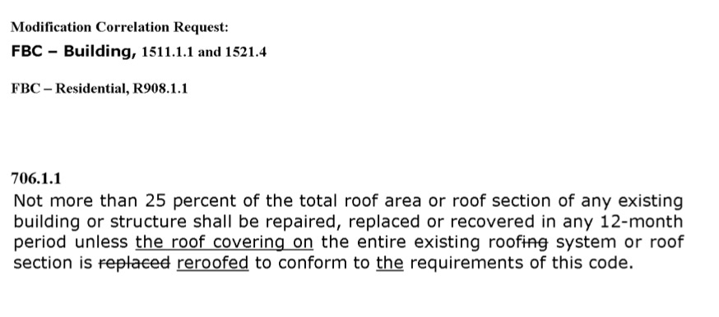

**From:** "[noreply@floridabuilding.org](mailto:noreply@floridabuilding.org)" <[noreply@floridabuilding.org](mailto:noreply@floridabuilding.org)>  
**Reply-To:** "[codes@floridabuilding.org](mailto:codes@floridabuilding.org)" <[codes@floridabuilding.org](mailto:codes@floridabuilding.org)>  
**Date:** Tuesday, October 25, 2022 at 10:55 AM  
**Subject:** Florida Building Code – Code development – Tracking Charts with TAC’s Action from the October 2022 Meetings

**To All Interested Parties:**

**RE:     8th Edition (2023) Florida Building Code – Code development –**

**Tracking Charts with TAC’s Action from the October 2022 Meetings**

**Request for Specific Code Modification to be Pulled of the Consent Agenda for Individual Consideration**

**_________________________________________________________________________**

This is to let you know that the actions and outcomes “Tracking Charts” from the October 2022 Commission’s Technical Advisory Committee (TACs) meetings on the proposed code changes with comments from the 2nd 45 day comment period to the 7th Edition (2020)  Florida Building Code, are now available from the following link:

<https://www.floridabuilding.org/fbc/thecode/2023_Code_Development/2023_Code_Development_Process.htm>

***Please note that the Building Code Information System (BCIS)/Proposed Code Modification Module has been updated to incorporate actions and outcomes from the October Commission’s TACs meetings.***

To review the TACs’ actions on specific proposed modification, please visit the following link:

<https://floridabuilding.org/cm/cm_default.aspx>

    For instructions on how to search for a specific mod using the BCIS/Proposed Code Modification Module, please use the “***2023 Quick     Reference Guide***” as available from the following link:

<https://floridabuilding.org/cm/cm_hottopics.aspx>

**Important:** If you are planning to request that specific Code change(s) to be pulled of the consent agenda for individual consideration by the Commission during its meeting of December 13-14, 2022, please submit your request in writing ***as soon as possible and no later than November 22, 2022.*** Requests should be sent to Mo Madani at [mo.madani@myfloridalicense.com](mailto:mo.madani@myfloridalicense.com).

Should you have any questions, we can be reached at (850) 487-1824.

Thank you!

Mo Madani, Technical Director

Building Codes and Standards Office

Florida Department of Business and Professional Regulations  
Building Codes and Standards  
<http://www.floridabuilding.org>